SÄLJ
Bild | Beskrivning | Säljes av
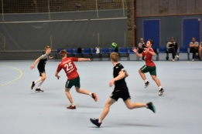 | Skjdhsdkfjhs sfkujhsdfkjhsdf jkhsgdfjhsgdf jhsdgfjhsdgf jksgdfjhs | Asjghsd tel: 0732554
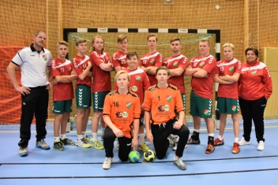 | Sdjkhfgsdhjf sdfjhsdf jhsdgfhjsdf jhfhjsdgfhsdgf bsdjhgsbdfjh | Xnxcgv mail: sdcjhkgsdfkhjsgdf

